Question Scheme Marks
number

1. 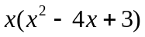 Factor of x. (Allow 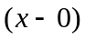) M1
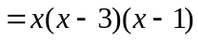 Factorise 3 term quadratic M1 A1
(3)

Total 3 marks

2. (a) 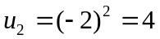 B1
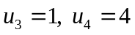 For 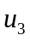, ft 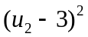 B1ft, B1
(3)
(b) 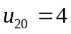 B1ft
(1)

Total 4 marks

3. (a) 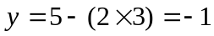 (or equivalent verification) (*) B1

(1)

(b) Gradient of L is 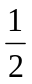 B1

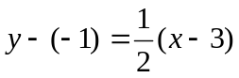 (ft from a changed gradient) M1 A1ft

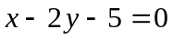 (or equiv. with integer coefficients) A1

(4)

Total 5 marks

Question Scheme Marks
number

4. (a) 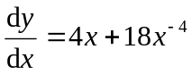 M1: 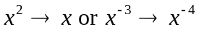 M1 A1

(2)

(b) 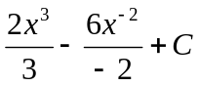 M1: 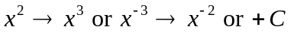 M1 A1 A1

(3)

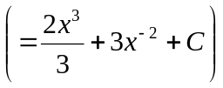 First A1: 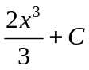

Second A1: 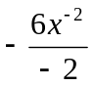

Total 5 marks

5. (a) 3√5 (or a = 3) B1

(1)

(b) 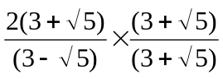 M1

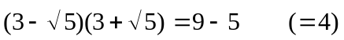 (Used as or intended as denominator) B1

(Independent) M1

or

[Correct version: 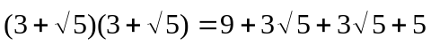, or double this.]

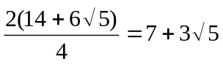 1st A1: b = 7, 2nd A1: c = 3 A1 A1

(5)

Total 6 marks

Question Scheme Marks
number

- (a) (See below) M1

Clearly through origin (or (0, 0) seen) A1

3 labelled (or (3, 0) seen) A1

3 (3)

(b)

6 Stretch parallel to y-axis M1

1 and 4 labelled (or (1, 0) and (4, 0) seen) A1

1 4 6 labelled (or (0, 6) seen) A1

(3)

(c)

Stretch parallel to x-axis M1

3 2 and 8 labelled (or (2, 0) and (8, 0) seen) A1

2 8 3 labelled (or (0, 3) seen) A1

(3)

Total 9 marks

7. (a) 500 + (500 + 200) = 1200 or 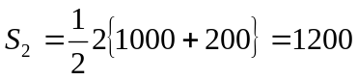 (*) B1 (1) (b) Using a = 500, d = 200 with n = 7, 8 or 9 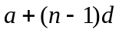 or “listing” M1

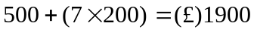 A1 (2)

(c) Using 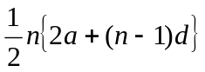 or 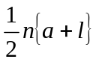, or listing and “summing” terms M1

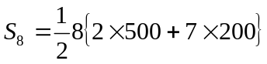 or 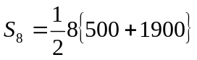, or all terms in list correct A1

= (£) 9600 A1 (3)

(d) 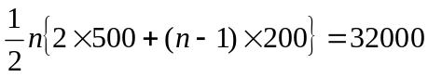 M1: General 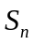, equated to 32000 M1 A1

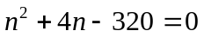 (or equiv.) M1: Simplify to 3 term quadratic M1 A1

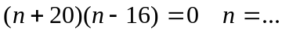 M1: Attempt to solve 3 t.q. M1

n = 16, Age is 26 A1cso,A1cso

(7)

Total 13 marks

Question Scheme Marks
number

8. 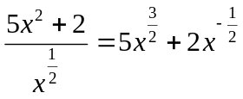 M1: One term correct. M1 A1

A1: Both terms correct, and no extra terms.

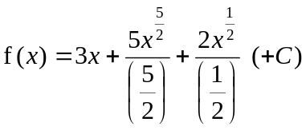 (+ C not required here) M1 A1ft

6 = 3 + 2 + 4 + C Use of x = 1 and y =6 to form eqn. in C M1

C = –3 A1cso

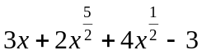 (simplified version required) A1 (ft C)

(7)

[or: 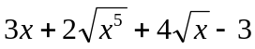 or equiv.]

Total 7 marks

9. (a) –2 (P), 2 (Q) (± 2 scores B1 B1) B1, B1

(2)

(b) 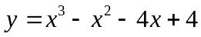 (May be seen earlier) Multiply out, giving 4 terms M1

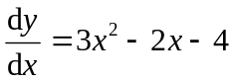 (*) M1 A1cso

(3)

(c) At x = –1: 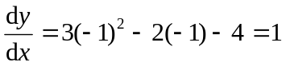

Eqn. of tangent: 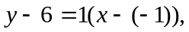 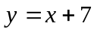 (*) M1 A1cso

(2)

(d) 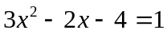 (Equating to “gradient of tangent”) M1

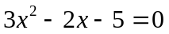 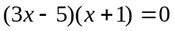 x = … M1

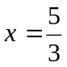 or equiv. A1

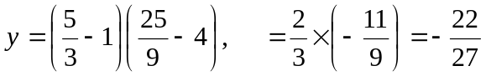 or equiv. M1, A1

(5)

Total 12 marks

Question Scheme Marks
number

10. (a) 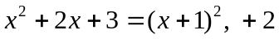 (a = 1, b = 2) B1, B1 (2)

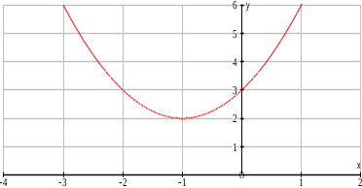
(b) “U”-shaped parabola M1

Vertex in correct quadrant (ft from (–a, b) A1ft

(0, 3) (or 3 on y-axis) B1 (3)

(c) 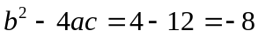 B1

Negative, so curve does not cross x-axis B1 (2)

(d) 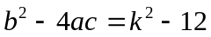 (May be within the quadratic formula) M1

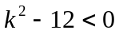 (Correct inequality expression in any form) A1

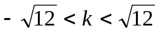 (or 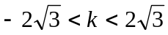) M1 A1 (4)

Total 11 marks

